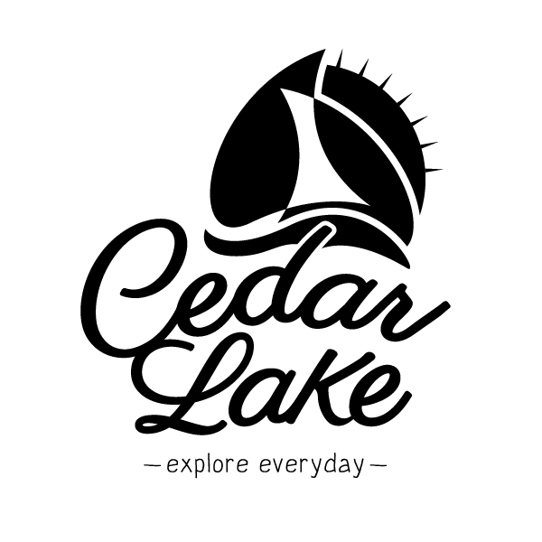
Town of Cedar Lake
Public Works
Cedar Lake Water Department
8550 Lake Shore Drive, Cedar Lake, IN 46303
PWSID# 5245067
Consumer Confidence Drinking Water Report
1-1-2023 to 12-31-2023

This is a report on the quality of the drinking water supplied by the Cedar Lake Water Utility for the fiscal year 2023. Questions regarding this report should be to the Cedar Lake Water Department at (219)-374-7478, Water Superintendent, Ryan Kuiper.

According to these assessments, your water system has a low risk of being susceptible to contamination. Further information about the source water assessment can be obtained by contacting Mr. Kevin Spindler of IDEM’s Drinking Water Branch at (317)-234-3243.

Cedar Lake Water Utility routinely monitors for contaminants in the drinking water according to Environmental Protection Agency and Indiana Department of Environmental Management requirements. These contaminants include:

- Microbial Contaminants, such as viruses and bacteria, which may come from sewage treatment plants, septic systems, agricultural livestock operations and wildlife.
- Inorganic Contaminants, such as salts and metals, which can be naturally occurring or result from urban storm water runoff, industrial or domestic wastewater discharges, oil and gas production, mining, or farming.
- Pesticides and Herbicides, which may come from a variety of sources such as agriculture, storm water runoff, and residential uses.
- Organic Chemical Contaminants, including synthetic and volatile organic chemicals, which are byproducts of industrial processes and petroleum productions, and can also result from gas stations, urban storm runoff and septic systems.
- Radioactive Contaminants, which can be naturally occurring or the result of oil and gas production and mining activities.

All sources of drinking water are subject to potential contamination by substances that are naturally occurring or manmade. These substances can be microbes, inorganic or organic chemicals and radioactive substances. All drinking water, including bottled water, may reasonably be expected to contain at least small amounts of some contaminants. The presence of contaminants does NOT necessarily indicate that the water poses and health risks. More information about contaminants and potential health effects can be obtained by calling the Environmental Protection Agency Safe Drinking Water Hotline at (800) 426-4791.

Where does my water come from? Between 60-72% of Indiana’s population relies on ground water for drinking and household use. The Cedar Lake Water Utilities source is the Silurian Devonian Aquifer. The Cedar Lake Water Utility has two (2) wells.
Our water system tested a minimum of 1 samples per month in accordance with the Total Coliform Rule for microbiological contaminants. With the microbiological samples collected, the water system collects disinfectant residuals to ensure control of microbial growth.

Disinfectant | Date | HighestRAA | Unit | Range | MRDL | MRDLG | Typical Source
CHLORINE | 2023 | 1 | ppm | 0.35 - 3 | 4 | 4 | Water additive used to control microbes

Lead and Copper
Definitions:
Action Level Goal (ALG): The level of a contaminant in drinking water below which there is no known or expected risk to health. ALGs allow for a margin of safety.
Action Level: The concentration of a contaminant which, if exceeded, triggers treatment or other requirements which a water system must follow.
Lead and Copper | Period | 90TH Percentile: 90% of your water utility levels were less than | Range of Sampled Results  (low - high) | Unit | AL | Sites Over AL | Typical Source
COPPER, FREE | 2021 - 2022 | 0.2694 | 0.0568 - 0.415 | ppm | 1.3 | 0 | Corrosion of household plumbing systems; Erosion of natural deposits; Leaching from wood preservatives
LEAD | 2021 - 2022 | 0 | 5.4 | ppb | 15 | 0 | Corrosion of household plumbing systems; Erosion of natural deposits

If present, elevated levels of lead can cause serious health problems, especially for pregnant women and young children. Lead in drinking water is primarily from materials and components associated with service lines and home plumbing. We are responsible for providing high quality drinking water, but we cannot control the variety of materials used in plumbing components. When your water has been sitting for several hours, you can minimize the potential for lead exposure by flushing your tap for 30 seconds to 2 minutes before using water for drinking or cooking. If you are concerned about lead in your water, you may wish to have your water tested. Information on lead in drinking water, testing methods, and steps you can take to minimize exposure is available from the Safe Drinking Water Hotline or at http://www.epa.gov/safewater/lead.

Regulated Contaminants
Radiological Contaminants |  | Collection Date |  | Highest Value |  | Range |  | Unit |  | MCL |  | MCLG |  | Typical Source
GROSS ALPHA, EXCL. RADON & U |  | 8/1/2018 |  | 4.3 |  | 4.3 |  | pCi/L |  | 15 |  | 0 |  | Erosion of natural deposits
RADIUM-228 |  | 8/1/2018 |  | 0.43 |  | 0.43 |  | PCI/L |  | 5 |  | 0
Regulated Contaminants | Collection Date |  | Highest Value |  | Range |  | Unit |  | MCL |  | MCLG |  | Typical Source
BARIUM | 3/15/2021 |  | 0.01 |  | 0.01 |  | ppm |  | 2 |  | 2 |  | Discharge of drilling wastes; Discharge from metal refineries; Erosion of natural deposits
DIBROMOCHLOROMETHANE | 9/25/2023 |  | 0.0057 |  | 0.0057 |  | MG/L |  | 0.1 |  | 0
FLUORIDE | 3/15/2021 |  | 0.54 |  | 0.54 |  | ppm |  | 4 |  | 4 |  | Erosion of natural deposits; Water additive which promotes strong teeth; Discharge from fertilizer and aluminum factories

Disinfection Byproducts | Sample Point |  | Period |  | Highest LRAA | Range |  | Unit | MCL |  | MCLG | Typical Source
TOTAL HALOACETIC ACIDS (HAA5) | 12747 WHEELER |  | 2022 - 2023 |  | 9 | 8.7 - 8.7 |  | ppb | 60 |  | 0 | By-product of drinking water disinfection
TTHM | 12747 WHEELER |  | 2022 - 2023 |  | 20 | 19.5 - 19.5 |  | ppb | 80 |  | 0 | By-product of drinking water chlorination

Some people may be more vulnerable to contaminants in drinking water than the general population. Immuno-compromised persons, such as persons with cancer undergoing chemotherapy, persons who have undergone organ transplants, people with HIV/AIDS or other immune system disorders, some elderly, and infants can be particularly at risk from infections. These people should seek advice about drinking water from their health care providers. U.S. Environmental Protection Agency and Centers for Disease Control guidelines on appropriate means to lessen the risk of infection by Cryptosporidium and other microbial contaminants are available from the Safe Drinking Water Hotline at (800) 426-4791.
Definitions: The following tables contain scientific terms and measures, some of which may require explanation.
Violations
During the period covered by this report we had the below noted violations.
Disinfection Byproducts | Sample Point | Period | Highest LRAA
TOTAL HALOACETIC ACIDS (HAA5) | 12747 WHEELER | 2022 - 2023 | 9
TTHM | 12747 WHEELER | 2022 - 2023 | 20
1/31/2023 - 2/27/2023 | E. COLI | MONITORING, ROUTINE, MAJOR (RTCR) | Failed to collect routine or replacement coliform samples
Violations were received for timeline violations. Samples were drawn, submitted and found acceptable.

Maximum Contaminant Level (MCL): Highest allowable amount of a contaminant that is allowed in drinking water.
Maximum Contaminant Level Goal (MCLG): Level of a contaminant in drinking water below which no known or expected risk to health exists. MCLG’s allow for a margin of safety.
Parts per Million (ppm): One part per million corresponds to one minute in two years.

Deficiencies
Unresolved significant deficiencies that were identified during a survey done on the water system are shown below.
Date Identified | Facility | Code | Activity | Due Date | Description
No deficiencies during this period.

